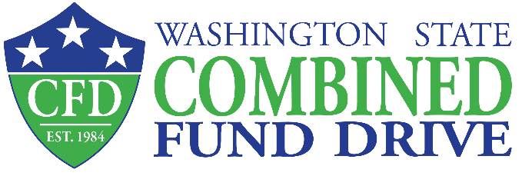
416 Sid Snyder Avenue SW
PO Box 40250
Olympia, WA 98504-0250
(360) 902-4162
cfd@sos.wa.gov
www.give.wa.gov

Fundraiser Transfer Form

Please complete the form below to transfer cash, check and credit card fundraiser dollars to the CFD.
- Hold ALL fundraiser donations in your agency CFD account until the end of your campaign or quarterly.
- Obtain the JV, IAP batch or check number and amount transferred from your agency fiscal contact.
- Log into your Campaign Leader profile and log your fundraiser(s) into the CFD online system. The
- Fundraiser total must match the amount your fiscal office reports for your fundraiser(s).
- Transfer all money, log your fundraiser, and submit this form on or before the December 8, 2023 deadline.
  - For fundraisers held outside the annual campaign, complete this step by the first Friday in March, June and September 2023.

1. Select your transfer method:
❐ JV Transfer – Obtain a JV number from your fiscal office to complete this form.
❐ IAP Transfer – Use SWV #0006745-17 for the IAP transfer and obtain the transfer number from your fiscal office to
complete this form.
❐ Check Transfer – Paper clip the check to this form and complete the fields below.
❐ Credit Card Transfer – Write “Credit Card” in the “IAP/Batch/JV/Check Number” field below to complete this form.

2. Please complete the fields below:
Agency/Institution Name:  Type Here |  | Date:  Type Here
Campaign Leader Name:  Type Here | Phone Number:  xxx-xxx-xxxx | Email:  Type Here
Agency Fiscal Contact Name:  Type Here | Phone Number:  xxx-xxx-xxxx | Email:  Type Here
Fundraiser Name:
Type Here
Total Amount Transferred:  $ Type Here | IAP/Batch/JV/Check Number:  Type Here

3. Submit fundraiser documents to the CFD office using a method below:

- Mail: Combined Fund Drive - PO Box 40250, Olympia, WA 98504-0250
OR
- E-mail: cfd@sos.wa.gov

Fundraisers held outside of the annual campaign must be reported quarterly.

